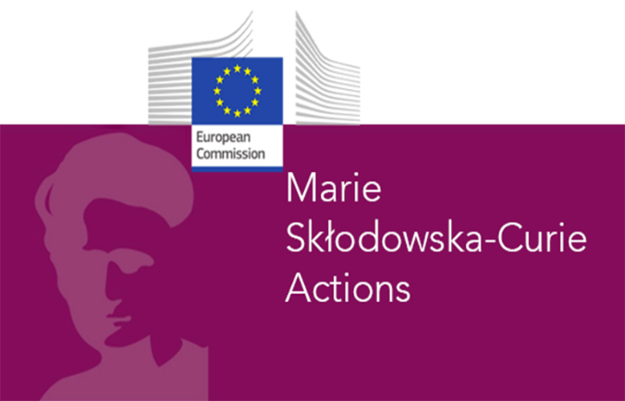
Grant agreement 101119261
DOCTORAL NETWORK
Applicant first name
Applicant last name
Year of master degree completion
University & lab of master degree
Title of master degree
Describe here in which country/ies you studied, worked and lived since September 2021
Indicate which Pharm-ERA PhD position you are applying for. Please rank positions in case of multiple application | TICK / RANK PhD n° Host institution Project title  1 AEIFORIA Assessing and predicting the fate of model PhACs and their TPs in soils and towards the aquatic systems  2 UTH Influence of PhAC exposure on microbial functions, diversity and AMR development and dissemination in soil  3 INRAE Incidence of PhACs and microbial coalescence on sediment microbial communities and the occurrence of bacterial pathogens disseminating antimicrobial resistances (AMR)  4 UGOT Fate and effects of the antibiotic sulfamethoxazole on sediment microbial communities: influence of availability of natural organic carbon  5 UVIC-UCC Dissemination routes of AMR and pathogens among terrestrial and freshwater ecosystems in agri-urban catchments.  6 CSIC-CEAB Influence of colonizing substrata on the dynamics of AMR and pathogens in fluvial ecosystems.  7 UFZ Molecular and phenotypic thresholds of antibiotics to protect aquatic microbial community structure and functioning  8 INRAE Kinetic of metabolomic fingerprints of periphyton exposed to PhACs: towards the discovery of early molecular biomarkers  9 CSIC-IDAEA Effect Directed Analysis on microbial communities as indicators of chemical and ecotoxicological quality status of the aquatic environment  10 KREATiS Assessment and prediction of the toxicity of PhACs on surface water and sediment model organisms
First referee – indicate laboratory + email
Second referee – indicate laboratory + email

